THE HENDERSON’S 2014 NEWSLETTER

Happy New Year to all our friends and kin,

May your 2015 be blessed in a very special way.

2014 has been filled with more trouble than we ever anticipated or wanted, but through all of this, God has been good.
In April, Shawn (our oldest son), suffered a fall, fracturing his skull and injuring his brain. He spent 10 days in Memorial Herman and was declared unable to drive or work. Progress has been slow and because he is relying on county medical care the frequency of seeing a Doctor is often slow. Thank God he has been getting some care and medication; however, he still suffers from dizziness, attention disorder and headaches. There are days when he is normal and other days when he is not so normal, but with God’s help, we know he will get better. Since the accident, we have been trying to get disability set in place for Shawn and after eight months, this could soon be a reality. Please continue to hold Shawn and our family in your prayers as we look forward to a great 2015!!

Among the other sad notes: in September we found it necessary to put our Shepherd/Wolf to sleep. We were paying more than $200 per month for her heart meds after she was diagnosed with congestive heart failure. Each night was a chore for her as she climbed the stairs to bed down for the night beside her favorite… Pat. It was one of the more difficult things that I personally ever had to do and for days I would shed a tear every time I thought of her, which was often. After fourteen years with a pet, they indeed become family and so to us, it was the equivalent of losing a family member. I guess you could say that God works in strange ways, because just before we had to put Shadow to sleep, a new dog came into our lives. Shawn found her wandering near a gas station several miles from our house. After trying for several weeks to find her owner without success, we declared “Little Bit” ours. She tops the scales at just under 8 lbs and is a terror when she does her best imitation of “watch dog”. Our internet search led us to the conclusion that she is a “Min Pin” or Miniature Doberman Pincher. The description of the Min Pin breed fits her to a T. Likes to be the dominate dog, will dart around like a balloon with air let out, will eat anything, don’t let her go through a crack or she will get out. God sent us a replacement for Shadow.

Speaking of family members, our loss was also felt as several high school class members left this realm, including: Billy Joe Robertson, Judy Farmer, and Mollie Carter.

For me personally, I continue to enjoy good health and try to play tennis everyday with my tennis buddy Rich. The only negative……Hey, Rich…..I’m tired of losing to you!!! Pat still works every day and has been keeping herself in good shape. Her work is often frustrating, but the drive to and from is very aggravating. Our traffic has continued to soar as more and more people move to Houston, Spring and The Woodlands. Every day I thank God for my wife Pat, who always strives to do every job with thoroughness and exactness. This includes cooking, with which she is a master!! Her enchiladas are better than most Mexican restaurants and I should weigh 300, but due to lucky genetics, I tip the scales under 160 (most of the time). Thank God for our 43 years of marriage in good times and bad.

Blake, our younger son, continues to work for Halliburton. His dreams of using art as his bread-winner are still just that…..dreams!! Halliburton has provided him with the ability to be self-sufficient and he is thankful for that. Enjoying the lower gas prices, but since Halliburton is an oil-related industry, we pray that Blake is able to maintain his job.
NEW YEAR’S RESOLUTIONS
Are made to be broken??? I would rather make a resolution for each new day. This is the day that the Lord hath made; let us rejoice and be glad in it!! This year has been the year of “dog troubles”, and one day last week I took Lady (our Dachshund/Chihuahua) to the Vet’s office. As I waited for the Vet, I turned my attention to an article in one of the Dog magazines. The article talked about New Year Resolutions and how if we want to deal with our problems, we can learn a lot from our dogs. So, after reading the article, I too plan to observe some of her suggestions:
- Enjoy the small things. Our own dogs enjoy a ride in the car and, in fact, get excited over the anticipation of going. When we come home (especially when it is Pat) the dogs get excited and greet us with their own version of smiles and laughter. Doesn’t that kind of perk you up? This is another of the things we can glean from our Dogs….. A really healthy greeting when we see our friends!!!
- Dogs are great at Reconciliation. What if we also forgave as quickly as our Dogs? How often have we scolded our dog, only to be forgiven soon after? So forgive someone in your life that you think has wronged you, even if you have to take the initiative.
- Enjoy the silliness of your dogs. Our two Dachshund/Chihuahua mixes each have their own silliness. Lady cannot be found no matter the calling; however, the second we have any indication of food, she comes flying out of hiding. Scooby, Lady’s brother, always comes and gets us when anyone else wants out, be it he or one of the others. The new addition, Little Bit, is our jumper/racer. She will jump on you and find a way to make you pay attention to her!! Like your dogs, enjoy some silliness in 2015, its good for you!!

So, as we end 2014 and begin a new year, may we resolve to be…….
MORE LIKE A DOG!!

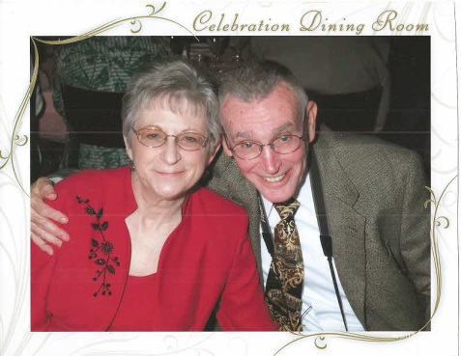 | 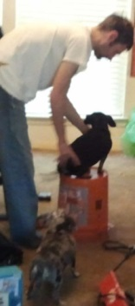  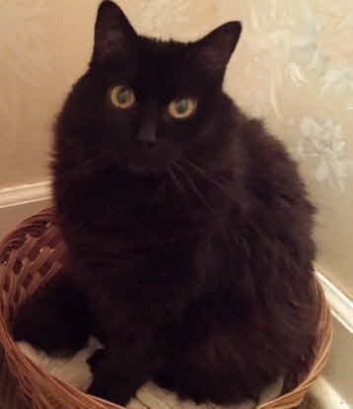  Vana Black  The Cat | 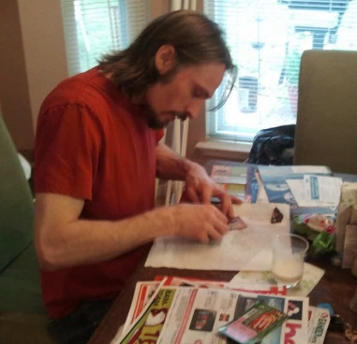
Pat and Don | Shawn, Scooby and Lady | Blake with scratch-off gifts
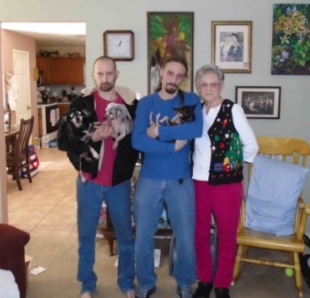  Scooby, Lady, Shawn, Blake,  Little Bit, Pat | 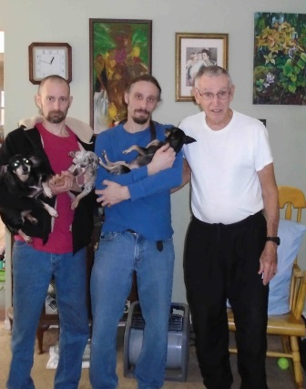  Shawn, Blake, Don | 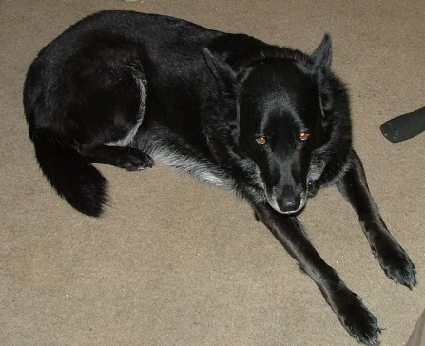  Goodbye from Shadow

With Love,
Don, Pat, Shawn, Blake, Scooby, Lady, Little Bit, and Vana Black (the Cat)

